-------------------------------------------------------

（英語）

**Niseko Town Halls's Guide to the Niseko Accommodation Tax**

Niseko Town is implementing an accommodation tax to provide a constant source of self-generated revenue to support the development of a sustainable and appealing tourist destination.

We aim to create initiatives that protect Niseko's environment and landscapes, enhancing the town's appeal as a safe, enriching and healing resort destination while also promoting sustainable tourism that aligns with residents' daily lives.

　If you have any inquiries, please feel free to contact us using the details below.

◆When will the accommodation tax come into effect?

**November 1st 2024**

◆Tax rate　*Tax rates vary by municipality.

|  |  |
| --- | --- |
| Accommodation fee (per person per night) | Tax amount |
| Below \5,001 | \100 |
| From \5,001 to \19,999 | \200 |
| From \20,000 to \49,999 | \500 |
| From \50,000 to \99,999 | \1,000 |
| From \100,000 | \2,000 |

*The accommodation fee does not include meal fees, facility usage fees or consumption tax etc.

◆How to pay accommodation tax　(Please choose the option that applies to your facility)

・Please pay the tax at the front desk of the hotel.

・Tax is included in the prepaid amount, no additional payment is required.

⇒As accommodation tax is paid to the accommodation facility and then paid to the Niseko Town Hall by accommodation facilities, customers are not required to undertake any procedures at the Niseko Town Hall.

◆Proposed uses of accommodation tax

　・Improve public transport services within the town

　・Support accommodation facilities renovation for energy efficiency.

　・Initiatives to protect the landscape and environment, and to ensure the safety of travellers.

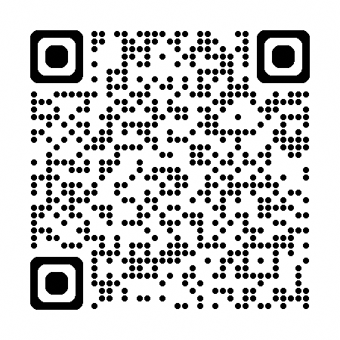　・Improve digital resources for easy travel.

　・Provisions towards natural disasters, pandemics etc.

◆Details　[https://www.town.niseko.lg.jp/kurashi/tax/syukuhakuzei](""""""""""""""https://www.town.niseko.lg.jp/kurashi/tax/syukuhakuzei"""""""""""""")

◆Inquiries

Tax related inquiries: Tax Division　 zeimu@town.niseko.lg.jp

Other inquiries: Commerce and Tourism Division kankou@town.niseko.lg.jp

TEL: 0136-44-2121

-------------------------------------------------------